**ASP.NET Web API Routing**

**ASP.NET Web API Routing**

In this article, I am going to discuss **ASP.NET Web API Routing**with examples. Please read our previous article where we discussed [**Cross-Origin Resource Sharing in Web AP**](https://dotnettutorials.net/lesson/cross-origin-resource-sharing-web-api/) with examples. The Routing in Web API is one of the most important concepts that you need to understand. Once you understand this concept, then you can easily learn the internal architecture of the ASP.NET Web API pipeline. As part of this article, we are going to discuss the following pointers in detail.

1. **What is Routing in Web API?**
2. **Understanding the Route Table.**
3. **How the Web API Framework handle an incoming HTTP Request?**

**What is Routing in Web API?**

The Web API Routing module is responsible for mapping the incoming HTTP requests to a particular controller action method. If you are familiar with the ASP.NET MVC application, then you can easily understand the Routing as it is very much similar to MVC routing.

The major difference between these two routing mechanisms is that the Web API uses the HTTP method, not the URI path, to select the action. You can also use MVC style routing in Web API which we will discuss in our upcoming articles.

**Understanding the Routing Table in ASP.NET Web API:**

In Web API application, a controller is a class that contains action methods that actually handle the incoming HTTP requests. The public methods of the controller class are called action methods or simply actions. When the Web API Framework receives an HTTP request, it routes that HTTP request to an action method of a controller.

To determine which action method to select or invoke for a particular HTTP Request, the WEB API Framework uses a Routing table. When we create a WEB API application, by default, the Visual Studio creates a default route for our application as shown in the below image.

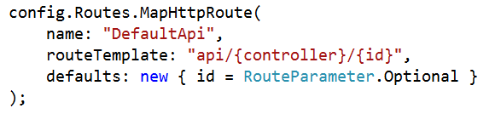

**The above route is defined in the WebApiConfig.cs file, which is present inside the App_Start folder.**

The routing table in Web API contains each and every route template that we define in the WebApiConfig file. The default route template for the Web API application is “**api/{controller}/{id}**“. In this template, the term “**api**” is a literal path segment, and the {controller} and {id} are placeholder variables that will be replaced with the actual value.

**How the Web API Framework handle an incoming HTTP Request?**

When the ASP.NET Web API Framework receives an HTTP request, it tries to match the URI against one of the route templates available in the routing table. If no route template matches the URI, then Web API Framework returns a 404 error to the client who actually makes the request. For example, the following URIs match with the default route template

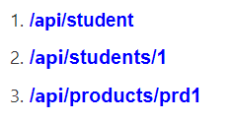

However, the following URI does not match, because it lacks the “**api**” segment:

**/products/1**

**Note:**

The reason for using “**api**” in the route is to avoid collisions between the Web API and MVC routing. So, you can have “**/products**” go to the MVC controller, and “**/api/products**” go to the Web API controller. Of course, if you don’t like this convention, you can change the default route table that also we will discuss.

Once a matching route is found in the Route table. The Web API Framework then selects the controller and the action. To find the controller, the Web API Framework adds “**Controller**” to the value of the **{controller}** variable. To find the action, the Web API Framework looks at the HTTP method and then looks for an action method whose name begins with that HTTP method name.

For example, with a **GET** request, the Web API Framework looks for an action that should start with “**Get**“, such as “GetProduct” or “GetAllProducts”. This convention only applies to **GET, POST, PUT,** and **DELETE** methods. You can enable other HTTP methods by using attributes on your controller that we will discuss in our upcoming article.

Other placeholder variables in the route template, such as **{id},** are mapped to action method parameters.

Let us see an example for a better understanding. Suppose you define the following Student controller

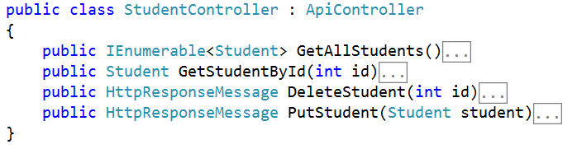

**Here are some possible HTTP requests, along with the action that gets invoked for each request.**

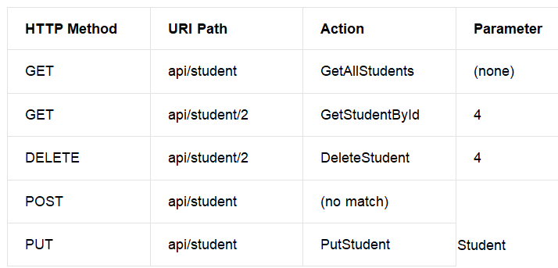

Notice that the **{id}** segment of the URI, if present, is mapped to the **id**parameter of the action. In our example, the  Student controller defines two GET methods, one with an **id** parameter and one with **no parameters**. It also defines one PUT method which takes one parameter of student type from the request body.

Here another point you need to understand is that the POST request will fail as the controller does not have any “**Post**” method.

**Routing Variations in WEB API**

**Routing Variations in Web API**

In this article, I am going to discuss **Routing Variations in WEB API** with some examples. Please read our previous article before proceeding to this article where we discussed the basics of [**Routing in WEB API**](https://dotnettutorials.net/lesson/routing-in-web-api/). As part of this article, we are going to discuss the following important pointers.

1. **Understanding HTTP Methods.**
2. **Routing Variation in Web API by Action Name.**
3. **Understanding the NonAction attribute in ASP.NET Web API.**

**Understanding HTTP Verbs in Web API.**

In the last article, we discussed using the default naming convention provided by Web API Framework. Instead of using the default naming convention for the HTTP methods, you can also explicitly specify the **HTTP method** for action by decorating the action method with the **HttpGet, HttpPut, HttpPost, or HttpDelete** attribute.

**Let us understand with an example.**

Please consider the following controller.

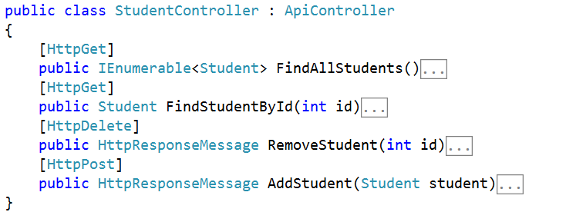

In the above example, the **FindAllStudents** and **FindStudentById** actions are mapped to the GET request, while the **RemoveStudent** action is mapped to DELETE Request and the **AddStudent** action is mapped to POST Request.

If you want to allow multiple HTTP verbs a single action method, or if you to allow HTTP methods other than the GET, PUT, POST, and DELETE, then you need to use the **AcceptVerbs** attribute, which takes a list of HTTP methods as shown in the below image

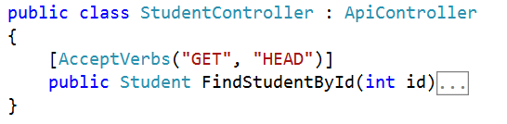

In the above example, the FindStudentById action method is mapped to both GET and HEAD HTTP Request.

**Routing Variation in Web API by Action Name**

With the default routing template, the Web API Framework uses the HTTP method to select the action. However, if you want you can also create your own route where the action name is included as part of the URI as shown in the below image.

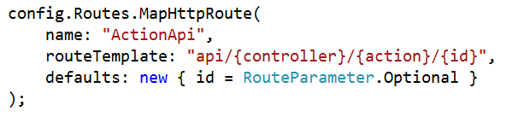

In the above route template, the **{action}** parameter names the action method on the controller. With this style of routing, you need to use the attributes to specify the allowed HTTP methods.

**Let us understand this with an example. Please consider the following controller.**

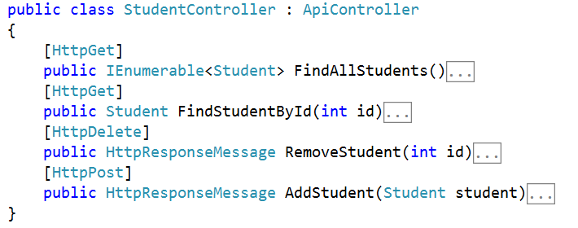

In the above example, a GET request for “**api/Student/FindAllStudents**” would map to the **FindAllStudents** action method.

In ASP.NET Web API by using the **ActionName** attribute you can also override the action method name. In the below Student Controller class, we have two actions which map to “**api/Student/Image**“. One action method supports the GET request while the other one supports the  POST HTTP request.

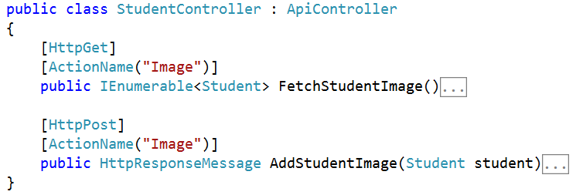

**Understanding the NonAction Attribute in ASP.NET Web API:**

If you want to prevent an action method from getting invoked as a response to an HTTP request, then you need to decorate that action with the **NonAction** attribute. This tells the Web API Framework that the method is not an action, even if it would match the routing rules.

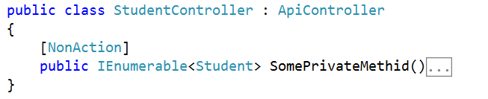

# Routing and Action Selection in Web API

## ****Routing and Action Selection in Web API****

The Routing module has three main phases:

1. Matching the URI to a route template.
2. Selecting a controller.
3. Selecting an action.

#### ****Route Templates****

A route template in WEB API looks very much similar to a URI path, but it can have placeholder values that are indicated with curly braces as shown in the below image.

Routing and Action Selection in Web API

When we create a route, it is also possible to provide default values for some or all of the placeholders as shown in the below image.

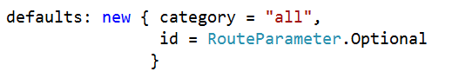

We can also provide some constraints which will restrict how a URI segment can match a placeholder as shown below.

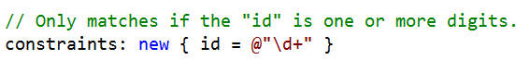

The WEB API Framework tries to match the segments in the URI path with the route template present in the Route table. The Literals in the template must match exactly. A placeholder matches any value unless we specify some constraints. The WEB API framework does not match other parts of the URI such as the hostname or the query parameters. The framework always selects the first route in the routing table that matches the URI.

There are two special placeholders used in WEB API such as “{controller}” and “{action}”.

1. The “{controller}” placeholder provides the name of the controller.
2. Similarly, the “{action}” placeholder provides the name of the action. In Web API, the usual convention is to omit the “{action}” placeholder. That’s why when you create a new WEB API application, and then you can see that the default route template created by the framework does not include the action placeholder.

##### ****Defaults****

If you provide a default value for a placeholder, then the route will match a URI that is missing those segments. For example:

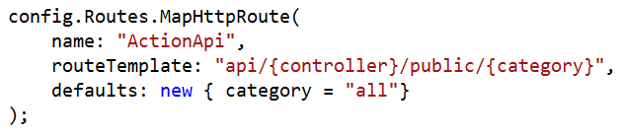

The URI “**http://localhost/api/student/public**” matches this route. The “{category}” segment is assigned the default value “all”.

##### ****Route Dictionary****

When the WEB API Framework finds a match for a URI, then it creates a dictionary that will contain the value for each placeholder. As we know the dictionary contains the data in the form of a key-value pair. Here, the keys are nothing but the placeholder names but excluding the curly braces and the values are taken from the URI path or from the defaults. The dictionary is stored in the **IHttpRouteData** object as shown below.

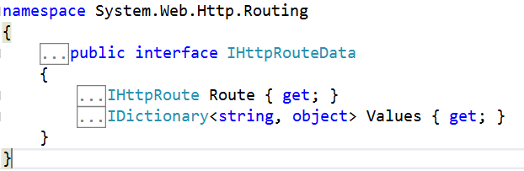

During the route-matching phase, the special placeholders such as “{controller}” and “{action}” are treated just like any other placeholders. They are simply stored in the dictionary with the other values.

A default can have a special value **RouteParameter.Optional**. If a placeholder assigned with this value, then the value will not be added to the route dictionary. For example:

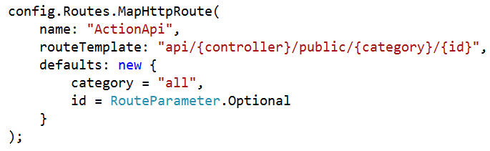

For the URI path “**api/student/public**“, the route dictionary will contain two elements such as:

1. controller: “student”
2. category: “all”

For the URI path “**api/student/public/cse/101**“, the route dictionary will contain three elements such as:

1. controller: “student”
2. category: “cse”
3. id: “101”

The defaults can also include a value that does not appear anywhere in the route template. If the route matches, that value is also get stored in the dictionary. For example:

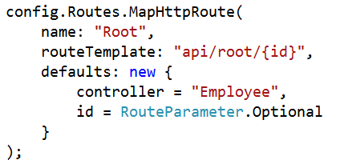

If the URI path is “**api/root/101**“, then the dictionary will contain two elements such as:

1. controller: “Employee”
2. id: “101”

##### ****Selecting a Controller****

The Controller selection in WEB API is handled by the **IHttpControllerSelector.SelectController method**.

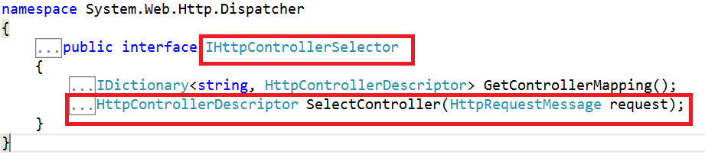

As shown in the above image the SelectController method takes an **HttpRequestMessage** instance as a parameter and returns an **HttpControllerDescriptor**. The default implementation for the above SelectController method is provided by the **DefaultHttpControllerSelector** class as shown in the below image.

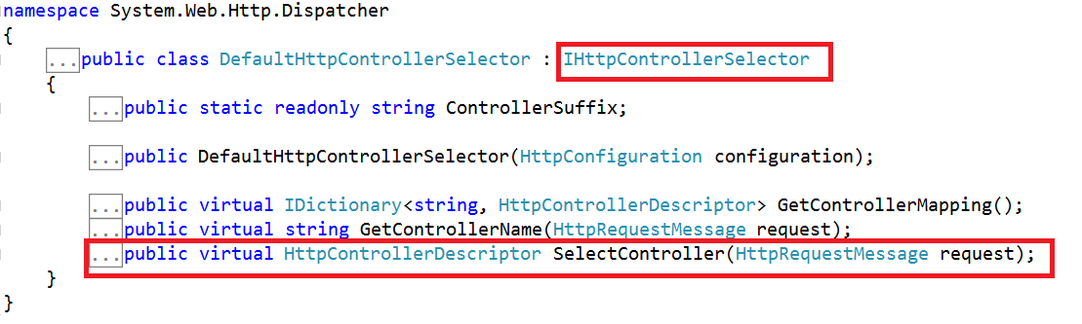

**The above class uses a straightforward algorithm to find the controller as:**

1. First, it will look at the route dictionary collection for the key “controller”.
2. Secondly, it takes the value for the “controller” key and appends the string “Controller” to get the controller type name.
3. Finally, it looks for a Web API controller with this type of name.

For example, if the route dictionary contains the key-value pair “controller” = “Student”, then the controller type is “StudentController”. If there is no matching type found, or it found multiple matches, then the ASP.NET WEB API Framework simply returns an error to the client.

#### ****Action Selection****

After selecting the controller, next, the WEB API Framework selects the action by calling the **IHttpActionSelector.SelectAction** method. This method takes an **HttpControllerContext** as a parameter and returns an **HttpActionDescriptor as shown in the below image**.

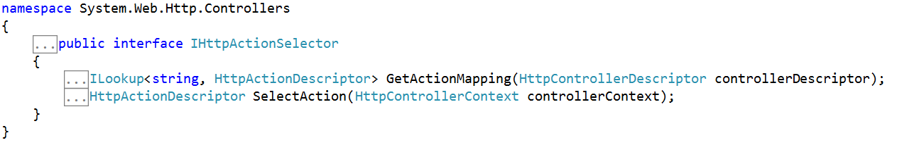

The default implementation for the **SelectAction** is provided by the **ApiControllerActionSelector** class as shown in the below image.

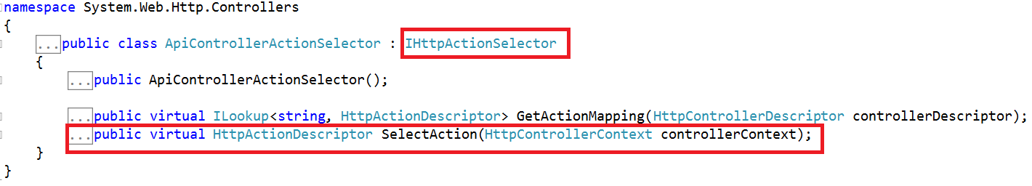

**To select an action, it looks at the following algorithm:**

1. The HTTP method of the request.
2. The “{action}” placeholder in the route template, if present.
3. The parameters of the actions on the controller.

Before looking at the selection algorithm, first, we need to understand **which methods on the controller class are considered as “actions” methods?**

When selecting an action, the WEB API Framework only looks at the public methods of the controller excluding the constructors, events, operator overloads, and so forth, and methods that are inherited from the **ApiController**class.

###### ****HTTP Methods:****

The WEB API Framework only chooses the action methods that match the HTTP method of the incoming request, determined as follows:

1. The actions which are decorated with the HTTP attribute such **AcceptVerbs, HttpDelete, HttpGet, HttpHead, HttpOptions**, **HttpPatch**, **HttpPost**, or **HttpPut**.
2. If the method names of the controller starts with “Get”, “Post”, “Put”, “Delete”, “Head”, “Options”, or “Patch”, then by convention the action supports that HTTP method.

##### ****Parameter Bindings:****

The parameter binding is how Web API creates value for a parameter. Here is the default rule for parameter binding:

1. Simple types are taken from the URI.
2. Complex types are taken from the request body.

It is also possible to change the default parameter binding in WEB API.

##### ****With that background, let see the action selection algorithm.****

1. Create a list of all the actions on the controller that match the HTTP request method.
2. If the route dictionary has an “action” entry, remove actions whose name does not match this value.
3. Try to match action parameters to the URI, as follows:
4. For each action, get a list of the parameters that are the simple type, where the binding gets the parameter from the URI. Exclude optional parameters.
5. From this list, try to find a match for each parameter name, either in the route dictionary or in the URI query string. Matches are case insensitive and do not depend on the parameter order.
6. Select an action where every parameter in the list has a match in the URI.
7. If more than one action meets these criteria, pick the one with the most parameter matches.
8. Ignore actions with the **[NonAction]** attribute.

Step3 is probably the most confusing step. The basic idea is that a parameter can get its value either from the URI or from the request body, or from a custom binding. For parameters that come from the URI, we want to ensure that the URI actually contains a value for that parameter, either in the path (via the route dictionary) or in the query string.

##### ****Example:****

Let us consider the above points with an example.

**Routes:**

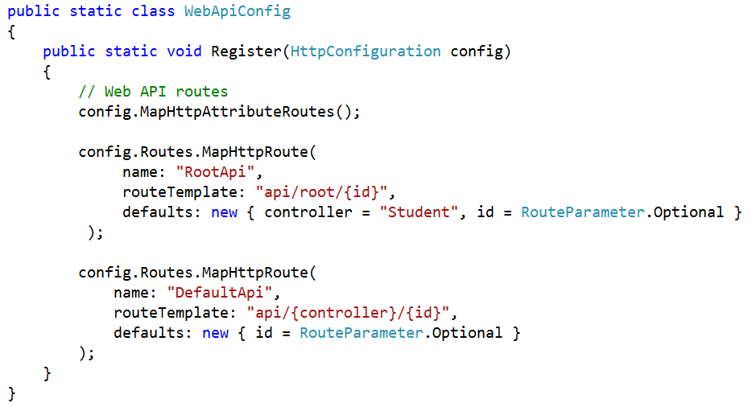

**Controller:**

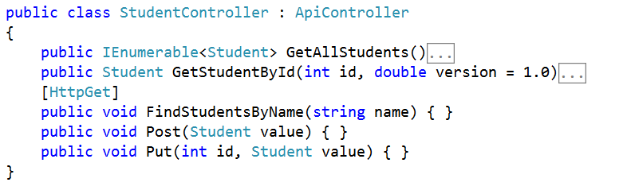

###### ****HTTP request:****

**GET http://localhost:50470/api/student/1?version=2.1&details=1**

##### ****Route Matching****

The above URI matches the route named “DefaultApi”. The route dictionary contains the following elements:

1. controller: “Student”
2. id: “1”

The route dictionary does not contain the query string parameters, “version” and “details”, but these will still be considered during action selection.

##### ****Controller Selection****

From the “controller” entry in the route dictionary, the WEB API Framework select the controller type is StudentController

###### ****Action Selection****

The above HTTP request is a GET request. The controller actions that support GET Request are GetAllStudents, GetStudentById, and FindStudentsByName. The route dictionary does not contain an entry for “action”, so we don’t need to match the action name.

Next, we need to match the parameter names for the actions, looking only at the GET actions.

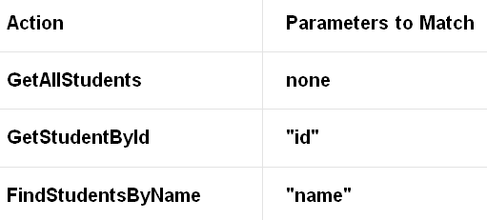

Notice that the version parameter of GetStudentById is not considered, because it is an optional parameter.

The GetAllStudents method matches trivially. The GetStudentById method also matches, because the route dictionary contains the “id”. The FindStudentsByName method does not match.

The GetStudentById method wins because it matches one parameter, versus no parameters for GetAllStudents. The method is invoked with the following parameter values:

1. id = 1
2. version = 2.1

Notice that even though the version was not used in the selection algorithm, the value of the parameter comes from the URI query string.

**Web API Attribute Routing**

**ASP.NET Web API Attribute Routing**

In this article, I am going to discuss **Web API Attribute Routing** with some examples. As we already discussed in the [**ASP.NET Web API Routing**](https://dotnettutorials.net/lesson/routing-in-web-api/) article that the Routing is a pattern matching mechanism to match an incoming HTTP Request to an action method of a controller.

The ASP.NET Web API 2 and ASP.NET MVC 5 supports a new type of routing called **attribute routing**. As the name implies, attribute routing means attributes are used to define routes. The Attribute routing provides more control over the URIs in your Web API application by defining routes directly on the actions and controllers. For example, you can easily create URIs that describes the hierarchies of resources.

The earlier style of routing called convention-based routing is still fully supported by Web API. In fact, you can combine both approaches in the same project.

In this article, we will discuss how to enable attribute routing in Web API and describes the various options for attribute routing.

**Why do we need Web API Attribute Routing?**

The first release of Web API uses the convention-based routing. In convention-based, we can define one or more route templates in the WebApiConfig file, which are basically parameterized strings. When the Web API Framework receives an HTTP request, it matches the URI against the route template that is available in the Route Table. For more information about convention-based routing, Please read the following articles where we discussed the Convention based [**Routing in Web API**](https://dotnettutorials.net/lesson/routing-in-web-api/) with examples.

One advantage of convention-based routing is that all the URI templates are defined in a single place, and the routing rules are applied consistently across all the controllers.

But the convention-based routing in Web API makes it hard to support certain URI patterns that are common in RESTful APIs. For example, resources often contain child resources: Customers have orders, movies have actors, books have authors, etc. It’s natural to create URIs that reflects these relations:

**Let’s understand this with an example.**

**Step1:** Create a new Web API application. Name it AttributeRoutingInWEBAPI

**Step2:** Right-click on the “Models” folder and add a class file with the name Student.cs and then copy and paste the following code.

**namespace** *AttributeRoutingInWEBAPI.Models*

**{**

**public** **class** Student

**{**

**public** **int** Id **{** **get**; **set**; **}**

**public** string Name **{** **get**; **set**; **}**

**}**

**}**

**Step3: Now, add Students Controller.**

To do so Right-click on the Controllers folder and add a new **Web API2 controller – Empty**. Name it StudentsController.cs. Copy and paste the following code.

**namespace** *AttributeRoutingInWEBAPI.Controllers*

**{**

**public** **class** StudentsController : ApiController

**{**

**static** List**<**Student**>** students = new List**<**Student**>()**

**{**

new Student**()** **{** Id = 1, Name = "Pranaya" **}**,

new Student**()** **{** Id = 2, Name = "Priyanka" **}**,

new Student**()** **{** Id = 3, Name = "Anurag" **}**,

new Student**()** **{** Id = 4, Name = "Sambit" **}**

**}**;

**public** IEnumerable**<**Student**>** Get**()**

**{**

**return** students;

**}**

**public** Student Get**(int** id**)**

**{**

**return** students.FirstOrDefault**(**s =**>** s.Id == id**)**;

**}**

**public** IEnumerable**<**string**>** GetStudentCourses**(int** id**)**

**{**

List**<**string**>** CourseList = new List**<**string**>()**;

**if** **(**id == 1**)**

CourseList = new List**<**string**>()** **{** "ASP.NET", "C#.NET", "SQL Server" **}**;

**else** **if** **(**id == 2**)**

CourseList = new List**<**string**>()** **{** "ASP.NET MVC", "C#.NET", "ADO.NET" **}**;

**else** **if** **(**id == 3**)**

CourseList = new List**<**string**>()** **{** "ASP.NET WEB API", "C#.NET", "Entity Framework" **}**;

**else**

CourseList = new List**<**string**>()** **{** "Bootstrap", "jQuery", "AngularJs" **}**;

**return** CourseList;

**}**

**}**

**}**

In Web API1, we had the convention-based routing that defines the routes using the route templates. When we create a new Web API project the Web API Framework creates a default route in the **WebApiConfig.cs** file. The default route is shown below

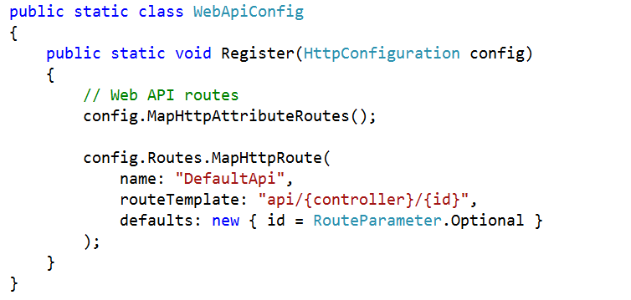

So with the above default route and the **StudentsController** in place **/api/students** is mapped to the **Get()** method of StudentsController as expected as shown in the below image.

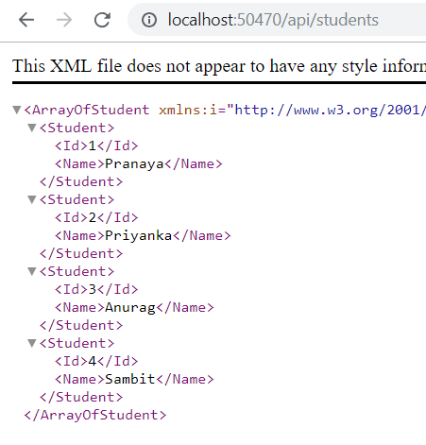

But when we navigate to **/api/students/1** we get the following exception message

**Multiple actions were found that match the request: Get on type AttributeRoutingInWEBAPI.Controllers.StudentsController GetStudentCourses on type AttributeRoutingInWEBAPI.Controllers.StudentsController**

This is because the Web API Framework does not know which of the 2 following action methods to map to the URI **/api/students/1**

**Get(int id) GetStudentCourses(int id)**

This can be very easily achieved by using the **Attribute Routing**. Here is what we want the WEB API Framework to do

1. URI **/api/students/1** should be mapped to **Get(int id)**. This method should return the student by id.
2. The URI **/api/students/1/courses** should be mapped to **GetStudentCourses(int id)**. This method should return the student courses by student id.

To achieve the above, we need to decorate the GetStudentCourses() action method with the [Route] attribute as shown in the below image

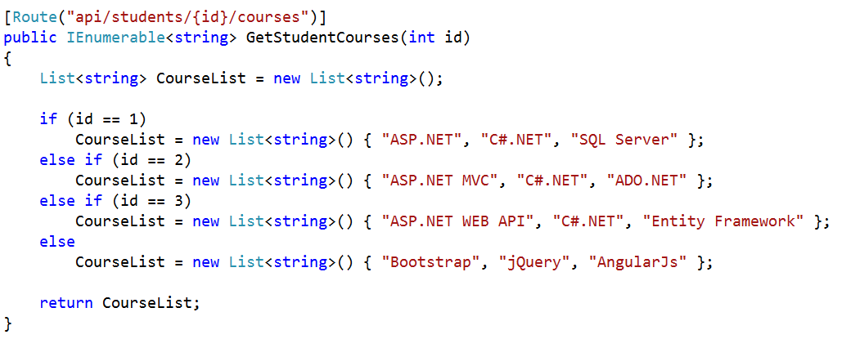

At this point build the solution and navigate to **/api/students/1**. Notice that, now you will get the student details whose id=1 and when you navigate to **/api/students/1/courses** you will get all the courses into which student with id=1 is enrolled.

Let us see some of the examples where attribute routing makes it easy.

**API versioning**

In the below example, the route “**/api/v1/students**” would be routed to a different controller than the “**/api/v2/students**” route.

**/api/v1/students**

**/api/v2/students**

**Overloaded URI segments**

In this example, “1” is an order number, but “pending” maps to a collection.

**/orders/1**

**/orders/pending**

**Multiple parameter types**

In this example, “1” is an order number, but “2013/06/16” specifies a date.

**/orders/1**

**/orders/2013/06/16**

**How to enable Web API Attribute Routing?**

In Web API 2, the Attribute Routing is enabled by default. The **config.MapHttpAttributeRoutes();** code which is present in **WebApiConfig.cs** file enables the Web API Attribute Routing.

We can also combine the Web API Attribute Routing with convention-based routing. To define convention-based routes, call the **MapHttpRoute** method as shown below.

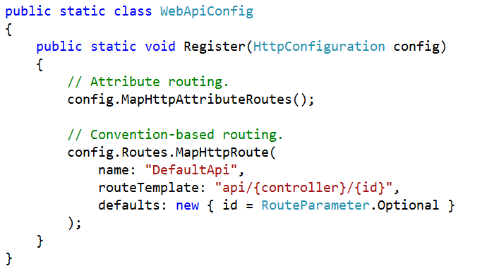

**Can we use both Attribute Routing and Convention-based routing in a single Web API project?**

Yes, We can combine both the routing mechanisms in a single ASP.NET Web API project. The controller action methods that have the [Route] attribute uses the Attribute Routing and the others without [Route] attribute uses Convention-based routing.

**Note:** You need to configure the Attribute routing before the convention-based routing in ASP.NET Web API.

**What are the advantages of using Web API Attribute Routing?**

1. It gives us more control over the URIs than convention-based routing. Creating URI patterns like hierarchies of resources (For example, students have courses, Departments have employees) is very difficult with convention-based routing.
2. Reduces the chances for errors, if a route is modified incorrectly in RouteConfig.cs then it may affect the entire application’s routing.
3. May decouple controller and action names from route entirely.
4. Easy to map two routes pointing to the same action.

**Optional Parameters in Web API Attribute Routing**

**Optional Parameters in Web API Attribute Routing**

In this article, I am going to discuss **Optional Parameters in Web API Attribute Routing** with some examples. Please read our [**previous article**](https://dotnettutorials.net/lesson/attribute-routing-in-web-api/) before proceeding to this article as we are going to work with the same example that we started in the [**Web API Attribute Routing**](https://dotnettutorials.net/lesson/attribute-routing-in-web-api/) article where we discussed the following things.

1. Why we need attribute routing?
2. What is Attribute Routing?
3. How to Implement Attribute Routing?
4. What are the advantages of using Attribute Routing?

**Optional Parameters in Web API Attribute Routing and Default Values:**

You can make a URI parameter as optional by adding a question mark (“?”) to the route parameter. If you make a route parameter as optional then you must specify a default value by using parameter = value for the method parameter.

We are going to work with the same example that we created in our last article. In our last article, we use the following Student Model

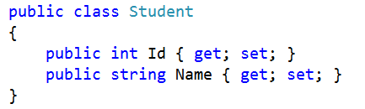

Along with we modify the WebApiConfig class as shown below.

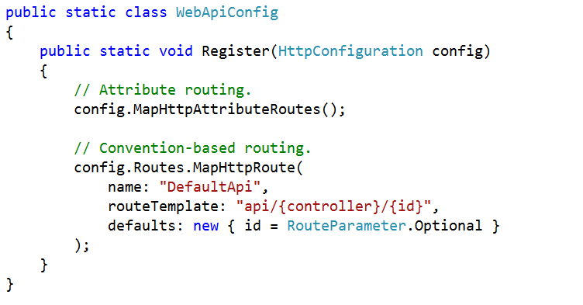

**Let’s modify the Student Controller as shown below.**

**namespace** *AttributeRoutingInWEBAPI.Controllers*

**{**

**public** **class** StudentsController : ApiController

**{**

**static** List**<**Student**>** students = new List**<**Student**>()**

**{**

new Student**()** **{** Id = 1, Name = "Pranaya" **}**,

new Student**()** **{** Id = 2, Name = "Priyanka" **}**,

new Student**()** **{** Id = 3, Name = "Anurag" **}**,

new Student**()** **{** Id = 4, Name = "Sambit" **}**

**}**;

// Optional URI Parameter with default value

// URL: /api/students

// URL: /api/students/1

**[**Route**(**"api/students/{stdid:int?}"**)]**

**public** Student GetBooksByID**(int** stdid = 1**)**

**{**

**return** students.FirstOrDefault**(**s =**>** s.Id == stdid**)**;

**}**

**}**

**}**

In the above example, **/api/students** and **/api/students/1** return the same resource. Alternatively, you can also specify a default value inside the route template as shown in the below image.

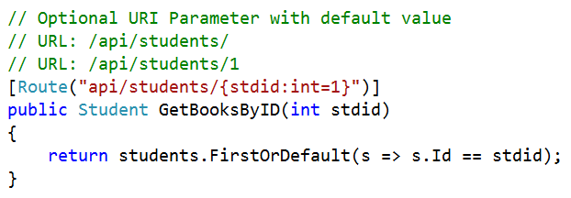

This is almost the same as the previous example, but there is a slight difference in the behavior when the default value is applied.

In the first example (**“{stdid?}”**), here the default value 1 is directly assigned to the action method parameter, so the method parameter will have this value exactly.

In the second example (**“{stdid=1}”**), the default value “1” assigned to the method parameter through the model-binding process. The default model-binder in Web API will convert the value “1” to the numeric value 1.

In most of the cases, unless you have custom model binders in your pipeline, the two forms will be equivalent.

**Route Prefix in Web API**

**Attribute Routing Route Prefix Web API**

In this article, I am going to discuss the **Attribute Routing Route Prefix in Web API** with some examples. We are going to work with the same example that we started in [**Web API Attribute Routing**](https://dotnettutorials.net/lesson/attribute-routing-in-web-api/)article and continue in [**Optional Parameters in Web API Attribute Routing**](https://dotnettutorials.net/lesson/optional-uri-parameters-in-attribute-routing/) article of this Web API article series. At the end of this article, you will understand What is Route Prefix in Web API and when and how to use Web API Route Prefix with an example.

**ASP.NET Web API Attribute Routing Route Prefix**

Let’s understand the use of Web API Attribute Routing Route Prefix with one example. Let’s modify the StudentController class as shown below.

**using** *System.Collections.Generic;*

**using** *System.Linq;*

**using** *System.Web.Http;*

**namespace** *AttributeRoutingInWEBAPI.Controllers*

**{**

**public** **class** StudentsController : ApiController

**{**

**static** List**<**Student**>** students = new List**<**Student**>()**

**{**

new Student**()** **{** Id = 1, Name = "Pranaya" **}**,

new Student**()** **{** Id = 2, Name = "Priyanka" **}**,

new Student**()** **{** Id = 3, Name = "Anurag" **}**,

new Student**()** **{** Id = 4, Name = "Sambit" **}**

**}**;

**[**HttpGet**]**

**[**Route**(**"students"**)]**

**public** IEnumerable**<**Student**>** GetAllStudents**()**

**{**

**return** students;

**}**

**[**HttpGet**]**

**[**Route**(**"students/{studentID}"**)]**

**public** Student GetStudentByID**(int** studentID**)**

**{**

Student studentDetails = students.FirstOrDefault**(**s =**>** s.Id == studentID**)**;

**return** studentDetails;

**}**

**[**HttpGet**]**

**[**Route**(**"students/{studentID}/courses"**)]**

**public** IEnumerable**<**string**>** GetStudentCourses**(int** studentID**)**

**{**

List**<**string**>** CourseList = new List**<**string**>()**;

**if** **(**studentID == 1**)**

CourseList = new List**<**string**>()** **{** "ASP.NET", "C#.NET", "SQL Server" **}**;

**else** **if** **(**studentID == 2**)**

CourseList = new List**<**string**>()** **{** "ASP.NET MVC", "C#.NET", "ADO.NET" **}**;

**else** **if** **(**studentID == 3**)**

CourseList = new List**<**string**>()** **{** "ASP.NET WEB API", "C#.NET", "Entity Framework" **}**;

**else**

CourseList = new List**<**string**>()** **{** "Bootstrap", "jQuery", "AngularJs" **}**;

**return** CourseList;

**}**

**}**

**}**

As you can see from the above example, we are using the route attributes at the action level to define the routes, and furthermore, all the routes in the **StudentsController** start with the same prefix – students that mean students is the common prefix for all the routes available in the Student Controller.

Here, you can set the common prefix “**students**” for the entire Student Controller by using the **[RoutePrefix]** attribute as shown below at the controller level.

**using** *System.Collections.Generic;*

**using** *System.Linq;*

**using** *System.Web.Http;*

**namespace** *AttributeRoutingInWEBAPI.Controllers*

**{**

**[**RoutePrefix**(**"students"**)]**

**public** **class** StudentsController : ApiController

**{**

**static** List**<**Student**>** students = new List**<**Student**>()**

**{**

new Student**()** **{** Id = 1, Name = "Pranaya" **}**,

new Student**()** **{** Id = 2, Name = "Priyanka" **}**,

new Student**()** **{** Id = 3, Name = "Anurag" **}**,

new Student**()** **{** Id = 4, Name = "Sambit" **}**

**}**;

**[**HttpGet**]**

**[**Route**]**

//This will be translated to /students

**public** IEnumerable**<**Student**>** GetAllStudents**()**

**{**

**return** students;

**}**

**[**HttpGet**]**

**[**Route**(**"{studentID}"**)]**

//This will be translated to /students/2

**public** Student GetStudentByID**(int** studentID**)**

**{**

Student studentDetails = students.FirstOrDefault**(**s =**>** s.Id == studentID**)**;

**return** studentDetails;

**}**

**[**HttpGet**]**

**[**Route**(**"{studentID}/courses"**)]**

//This will be translated to /students/2/course

**public** IEnumerable**<**string**>** GetStudentCourses**(int** studentID**)**

**{**

List**<**string**>** CourseList = new List**<**string**>()**;

**if** **(**studentID == 1**)**

CourseList = new List**<**string**>()** **{** "ASP.NET", "C#.NET", "SQL Server" **}**;

**else** **if** **(**studentID == 2**)**

CourseList = new List**<**string**>()** **{** "ASP.NET MVC", "C#.NET", "ADO.NET" **}**;

**else** **if** **(**studentID == 3**)**

CourseList = new List**<**string**>()** **{** "ASP.NET WEB API", "C#.NET", "Entity Framework" **}**;

**else**

CourseList = new List**<**string**>()** **{** "Bootstrap", "jQuery", "AngularJs" **}**;

**return** CourseList;

**}**

**}**

**}**

The Route Prefix attribute eliminates the need to repeat the common prefix “students” on each and every controller action method. However, sometimes we may need to override the route prefix attribute. Let us understand this with an example

First, add a class file with the name “**Teacher.cs”**within the Models Folder**.**To do so right-click on the model’s folder, and then add a new class file with the name **“Teacher.cs”.** Then Copy and paste the following code in it.

**namespace** *AttributeRoutingInWEBAPI.Models*

**{**

**public** **class** Teacher

**{**

**public** **int** Id **{** **get**; **set**; **}**

**public** string Name **{** **get**; **set**; **}**

**}**

**}**

Add the below **GetTeachers()** action method within the **“StudentsController”**.

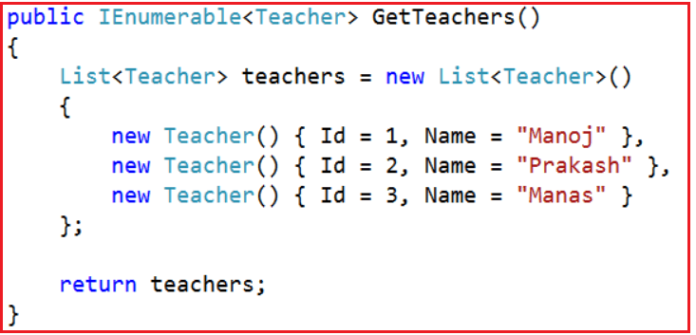

After adding the **GetTeachers()** action in the **“StudentsController”** class, we want **GetTeachers() action**to be mapped to the URI “**tech/teachers**“.

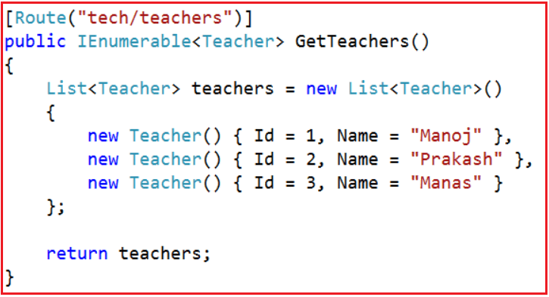

If we use the **[Route]** attribute on **GetTeachers()** method as shown in the above image and when we navigate to **tech/teachers**, we get the following error.

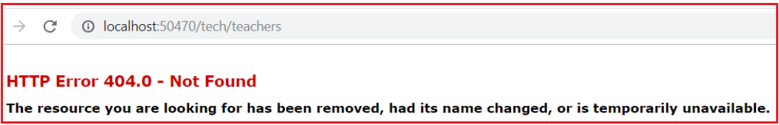

But if we navigate to **/students/tech/teachers** then we get the output as expected that the list of teachers. This is because the **[RoutePrefix(“students”)]** attribute on StudentsController. Now the question that comes to our mind is how to override the RoutePrefix attribute used in the StudentsController. To override the RoutePrefix we need to use the **~** (tilde) symbol as shown below.

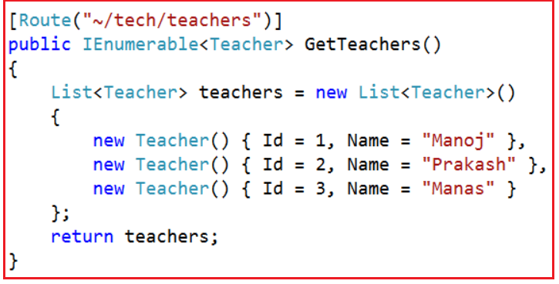

With the above change, now the GetTeachers() action method is mapped to URI “**/tech/teachers**” as expected.

**What is the use of the RoutePrefix attribute?**

The RoutePrefix attribute is used to specify the common route prefix at the controller level to eliminate the need to repeat the common route prefix on each and every controller action.

**How to override the route prefix?**

Use ~ character to override the route prefix

**Web API Attribute Routing Route Constraints**

**ASP.NET Web API Attribute Routing Route Constraints**

In this article, I will discuss the **Web API Attribute Routing Route Constraints**with examples. We are going to work with the same example that we worked in our previous articles. So, please read the following articles before proceeding to this article.

[**Attribute Routing in Web API**](https://dotnettutorials.net/lesson/attribute-routing-in-web-api/)

[**Optional URI Parameters and Default values in Attribute Routing**](https://dotnettutorials.net/lesson/optional-uri-parameters-in-attribute-routing/)

[**Attribute Routing Route Prefix in WEB API**](https://dotnettutorials.net/lesson/attribute-routing-route-prefix-web-api/)

**Web API Attribute Routing Route Constraints**

The Web API Attribute Routing Route Constraints are nothing but a set of rules that we can apply on our routing parameters to restrict how the parameters in the route template are matched. The general syntax is

**{parameter:constraint}**

**Let us understand ASP.NET Web API Attribute Routing Route Constraints with one example.**

Let’s modify the Students Controller as shown below.

**namespace** *AttributeRoutingInWEBAPI.Controllers*

**{**

**[**RoutePrefix**(**"students"**)]**

**public** **class** StudentsController : ApiController

**{**

**static** List**<**Student**>** students = new List**<**Student**>()**

**{**

new Student**()** **{** Id = 1, Name = "Pranaya" **}**,

new Student**()** **{** Id = 2, Name = "Priyanka" **}**,

new Student**()** **{** Id = 3, Name = "Anurag" **}**,

new Student**()** **{** Id = 4, Name = "Sambit" **}**

**}**;

**[**HttpGet**]**

**[**Route**(**"{studentID}"**)]**

**public** Student GetStudentDetails**(int** studentID**)**

**{**

Student studentDetails = students.FirstOrDefault**(**s =**>** s.Id == studentID**)**;

**return** studentDetails;

**}**

**}**

**}**

Now, if we navigate to **/students/1** URI, then the **GetStudentDetails(int studentID)** action is executed and we get the details of the student whose id is 1 as expected.

Let’s change our business requirement, in addition to retrieving the student details by “**student Id**”, we also want to retrieve the student details by “**student Name**“. So let’s add another GetStudentDetails() action method with a string parameter as shown below.

**namespace** *AttributeRoutingInWEBAPI.Controllers*

**{**

**[**RoutePrefix**(**"students"**)]**

**public** **class** StudentsController : ApiController

**{**

**static** List**<**Student**>** students = new List**<**Student**>()**

**{**

new Student**()** **{** Id = 1, Name = "Pranaya" **}**,

new Student**()** **{** Id = 2, Name = "Priyanka" **}**,

new Student**()** **{** Id = 3, Name = "Anurag" **}**,

new Student**()** **{** Id = 4, Name = "Sambit" **}**

**}**;

**[**HttpGet**]**

**[**Route**(**"{studentID}"**)]**

**public** Student GetStudentDetails**(int** studentID**)**

**{**

Student studentDetails = students.FirstOrDefault**(**s =**>** s.Id == studentID**)**;

**return** studentDetails;

**}**

**[**HttpGet**]**

**[**Route**(**"{studentName}"**)]**

**public** Student GetStudentDetails**(**string studentName**)**

**{**

Student studentDetails = students.FirstOrDefault**(**s =**>** s.Name == studentName**)**;

**return** studentDetails;

**}**

**}**

**}**

At this point build the solution, and navigate to the following URI’s

**/students/1**

**/students/Pranaya**

**In both the cases we will get the below error:**

**Multiple actions were found that match the request: GetStudentDetails on type AttributeRoutingInWEBAPI.Controllers.StudentsController GetStudentDetails on type AttributeRoutingInWEBAPI.Controllers.StudentsController**

This is because the WEB API Framework does not know or does not identify which version of the GetStudentDetails() action method to use. This is the situation where the route constraints play a very important role.

If an integer is specified in the URI like **/students/1**, then we need to execute the GetStudentDetails(int studentId) action method which takes an integer parameter whereas if a string is specified in the URI like **/students/Pranaya**, then we need to execute the GetStudentDetails(string studentName) action method which takes the parameter of type string.

This can be very easily achieved using Attribute Route Constraints in the WEB API application. To specify the attribute route constraint, the syntax is **“{parameter:constraint}**“. With these constraints in place, if the parameter segment in the URI is an integer, then the GetStudentDetails(int studentId) action method with integer parameter is invoked and if it is a string value then the GetStudentDetails(string studentName) action method with string parameter is invoked.

**Let’s modify the Student Controller to use the Attribute Route Constraints as shown below to achieve the above requirements.**

**namespace** *AttributeRoutingInWEBAPI.Controllers*

**{**

**[**RoutePrefix**(**"students"**)]**

**public** **class** StudentsController : ApiController

**{**

**static** List**<**Student**>** students = new List**<**Student**>()**

**{**

new Student**()** **{** Id = 1, Name = "Pranaya" **}**,

new Student**()** **{** Id = 2, Name = "Priyanka" **}**,

new Student**()** **{** Id = 3, Name = "Anurag" **}**,

new Student**()** **{** Id = 4, Name = "Sambit" **}**

**}**;

**[**HttpGet**]**

**[**Route**(**"{studentID:int}"**)]**

**public** Student GetStudentDetails**(int** studentID**)**

**{**

Student studentDetails = students.FirstOrDefault**(**s =**>** s.Id == studentID**)**;

**return** studentDetails;

**}**

**[**HttpGet**]**

**[**Route**(**"{studentName:alpha}"**)]**

**public** Student GetStudentDetails**(**string studentName**)**

**{**

Student studentDetails = students.FirstOrDefault**(**s =**>** s.Name == studentName**)**;

**return** studentDetails;

**}**

**}**

**}**

Now build the solution, and navigate to the following two URIs and see everything is working as expected.

**/students/1**

**/students/Pranaya**

Please note that “**alpha**” stands for uppercase or lowercase alphabet characters. Along with alpha and int, you can also use constraints such as decimal, float, long, double, bool, etc. Please check the following MSDN link for the full list of available constraints in web API.

[**https://docs.microsoft.com/en-us/aspnet/web-api/overview/web-api-routing-and-actions/attribute-routing-in-web-api-2#route-constraints**](https://docs.microsoft.com/en-us/aspnet/web-api/overview/web-api-routing-and-actions/attribute-routing-in-web-api-2#route-constraints)

**Example:**

If you want GetStudentDetails(int studentId) action method to be mapped to URI **/students/{studentId}**, only if the studentId is a number greater than ZERO, then use the “min” constraint as shown below.

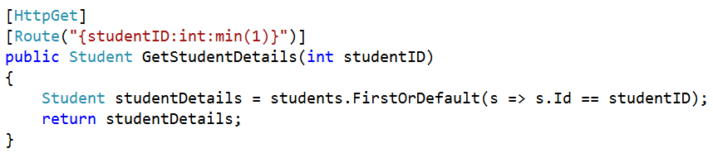

With the above change, if we specify a positive number like 1 in the URI, then it will be mapped to the GetStudentDetails(int studentID) action method as expected

**/students/1**

However, if we specify 0 or a negative number less than ZERO, then we will get an error. For example, if we specify 0 as the value for studentID in the URI,

**/students/0**

**We will get the below error**

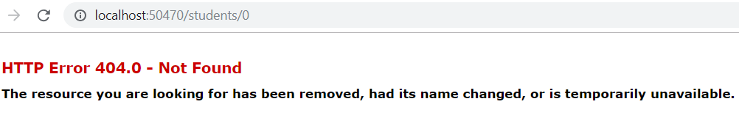

Along with the “**min**” constraint, you can also specify the “**max**” constraint as shown below. For example, if you want the studentID value in the URI to be between 1 and 3 inclusive, then you can specify both “**min**” and “**max**” constraints as shown below.

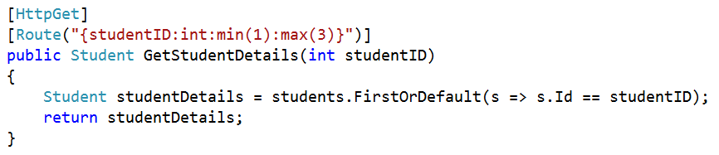

**The above example can also be achieved using the “range” attribute as shown below**

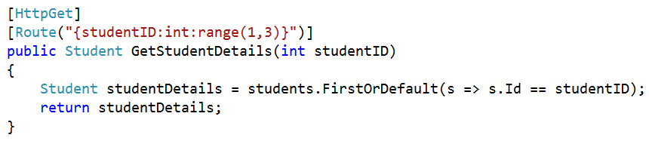

**Custom Web API Route Constraints in Attribute Routing**

You can also create custom route constraints in Web API and to do so you need to implement the **IHttpRouteConstraint** interface. For example, the below constraint will restrict a parameter value to a non-zero integer value.

**using** *System;*

**using** *System.Collections.Generic;*

**using** *System.Globalization;*

**using** *System.Net.Http;*

**using** *System.Web.Http.Routing;*

**namespace** *AttributeRoutingInWEBAPI.Models*

**{**

**public** **class** NonZeroConstraint : IHttpRouteConstraint

**{**

**public** **bool** Match**(**HttpRequestMessage request, IHttpRoute route, string parameterName,

IDictionary**<**string, **object>** values, HttpRouteDirection routeDirection**)**

**{**

**object** **value**;

**if** **(**values.TryGetValue**(**parameterName, out **value)** && **value** != **null)**

**{**

**long** longValue;

**if** **(value** **is** **long)**

**{**

longValue = **(long)value**;

**return** longValue != 0;

**}**

string valueString = Convert.ToString**(value**, CultureInfo.InvariantCulture**)**;

**if** **(**Int64.TryParse**(**valueString, NumberStyles.Integer,

CultureInfo.InvariantCulture, out longValue**))**

**{**

**return** longValue != 0;

**}**

**}**

**return** **false**;

**}**

**}**

**}**

**The following code shows how to register the custom constraint:**

**namespace** *AttributeRoutingInWEBAPI*

**{**

**public** **static** **class** WebApiConfig

**{**

**public** **static** **void** Register**(**HttpConfiguration config**)**

**{**

var constraintResolver = new DefaultInlineConstraintResolver**()**;

constraintResolver.ConstraintMap.Add**(**"nonzero", typeof**(**NonZeroConstraint**))**;

// Attribute routing.

config.MapHttpAttributeRoutes**(**constraintResolver**)**;

// Convention-based routing.

config.Routes.MapHttpRoute**(**

name: "DefaultApi",

routeTemplate: "api/{controller}/{id}",

defaults: new **{** id = RouteParameter.Optional **}**

**)**;

**}**

**}**

**}**

Now you can apply the custom constraint in your routes as shown below.

**[**HttpGet**]**

**[**Route**(**"{studentName:alpha}"**)]**

**public** Student GetStudentDetails**(**string studentName**)**

**{**

Student studentDetails = students.FirstOrDefault**(**s =**>** s.Name == studentName**)**;

**return** studentDetails;

**}**

**Route Names and Route Orders in Attribute Routing**

**Route Names and Route Orders in Attribute Routing**

In this article, I will discuss the **Route Names and Route Orders in Attribute Routing** with examples. We are going to work with the same example that we worked in our previous articles. So if you have not read those articles then I strongly recommend you to read the following articles before proceeding to this article.

[**Attribute Routing in Web API**](https://dotnettutorials.net/lesson/attribute-routing-in-web-api/)

[**Optional URI Parameters and Default values in Attribute Routing**](https://dotnettutorials.net/lesson/optional-uri-parameters-in-attribute-routing/)

[**Attribute Routing Route Prefix in WEB API**](https://dotnettutorials.net/lesson/attribute-routing-route-prefix-web-api/)

[**Route Constraints in Attribute Routing**](https://dotnettutorials.net/lesson/web-api-route-constraints-attribute-routing/)

**Route Names**

In ASP.NET Web API, each and every route has a name. The Route names are useful for generating links so that you can include a link in an HTTP response.

To specify the route name, we need to set the Name property on the attribute. Let us see an example to understand how to set the route name, and also how to use the route name when generating a link.

**namespace** *AttributeRoutingInWEBAPI.Controllers*

**{**

**public** **class** StudentsController : ApiController

**{**

**static** List**<**Student**>** students = new List**<**Student**>()**

**{**

new Student**()** **{** Id = 1, Name = "Pranaya" **}**,

new Student**()** **{** Id = 2, Name = "Priyanka" **}**,

new Student**()** **{** Id = 3, Name = "Anurag" **}**,

new Student**()** **{** Id = 4, Name = "Sambit" **}**

**}**;

**[**HttpGet**]**

**[**Route**(**"{studentID:nonzero}", Name = "GetStudentById"**)]**

**public** Student GetStudentDetails**(int** studentID**)**

**{**

Student studentDetails = students.FirstOrDefault**(**s =**>** s.Id == studentID**)**;

**return** studentDetails;

**}**

**[**Route**(**"api/students"**)]**

**public** HttpResponseMessage Post**(**Student student**)**

**{**

students.Add**(**student**)**;

var response = Request.CreateResponse**(**HttpStatusCode.Created**)**;

// Generate a link for the new student and set the Location header in the response.

string uri = Url.Link**(**"GetStudentById", new **{** studentID = student.Id **})**;

response.Headers.Location = new Uri**(**uri**)**;

**return** response;

**}**

**}**

**}**

**Let’s test this using Fiddler.**

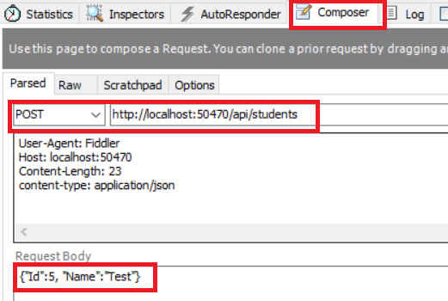

Then click on the execute button. It will give us the below result.

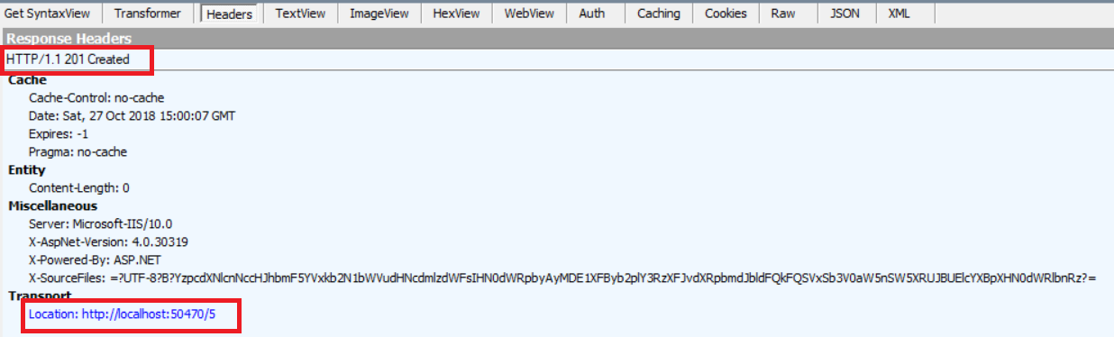

**Route Order**

When the WEB API Framework tries to match a URI with a route, it evaluates the routes in a particular order. To specify the order, set the **Order** property on the route attribute. Lower values are evaluated first. The default order value is zero.

**Here is how the total ordering is determined:**

1. Compare the **Order** property of the route attribute.
2. Look at each URI segment in the route template. For each segment, order as follows:
3. Literal segments.
4. Route parameters with constraints.
5. Route parameters without constraints.
6. Wildcard parameter segments with constraints.
7. Wildcard parameter segments without constraints.
8. In the case of a tie, routes are ordered by a case-insensitive ordinal string comparison (OrdinalIgnoreCase) of the route template.

**Here is an example. Suppose you define the following controller:**

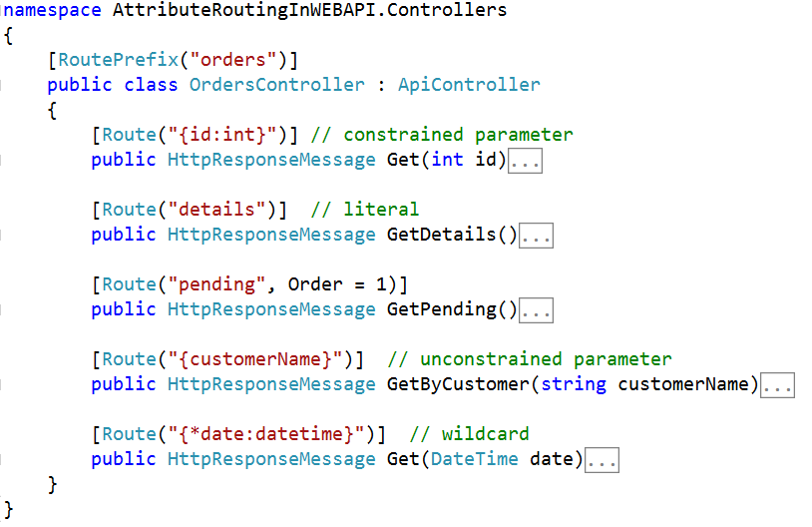

**These routes are ordered as follows.**

1. orders/details
2. orders/{id}
3. orders/{customerName}
4. orders/{*date}
5. orders/pending

Notice that “details” is a literal segment and appears before “{id}”, but “pending” appears last because the **Order** property is 1. (This example assumes there are no customers named “details” or “pending”. In general, try to avoid ambiguous routes. In this example, a better route template for GetByCustomeris “customers/{customerName}” )